CSC8502 Resit Coursework

Srichand Dontha

21033252

Note: solution is in Cubemap tutorial

Features Included:

* The Scene landscape is rendered using a blendmap which uses four textures in the fragment shader.
* Ambient lighting
* Diffuse lighting
* Specular lighting
* Automatic and Manual Camera Movement
* Meshes used in screen
* Two skyboxes
* Directional light
* Use of advanced buffers
* Day/Night effect using fading between cubemaps
* Bonfire using Geometry Shader

Key Bindings:

W,A,S,D – To manually move the camera around

Shift – Traverse up using camera

Spacebar – Traverse down using camera

M,N – Shift/Toggle between morning and night

M – start the day timer which goes till night.

N – start the night timer which goes till morning.

Screeshots:

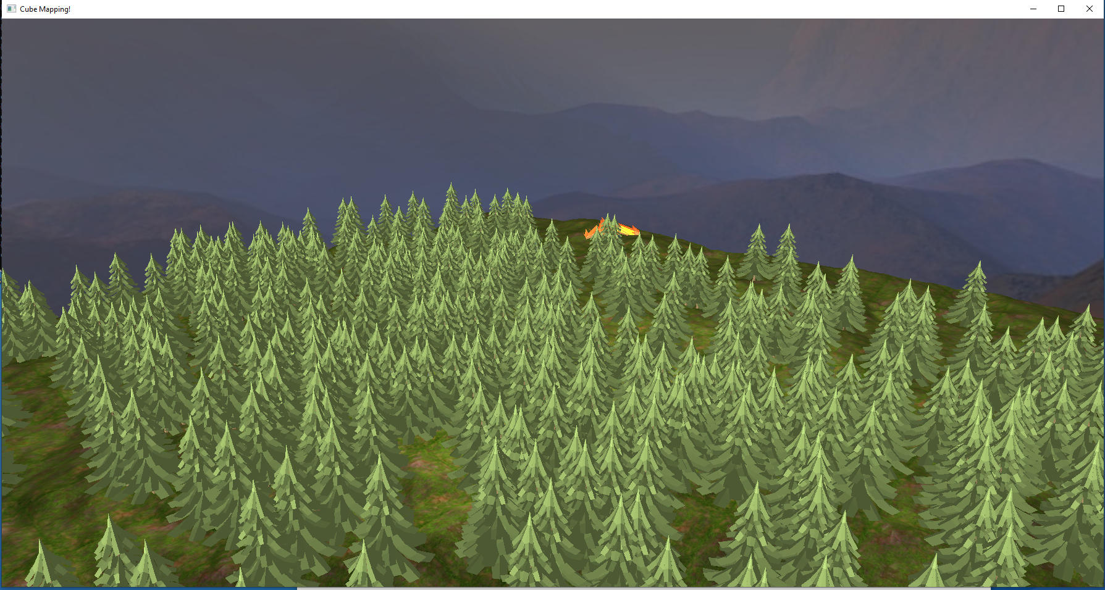

Day time

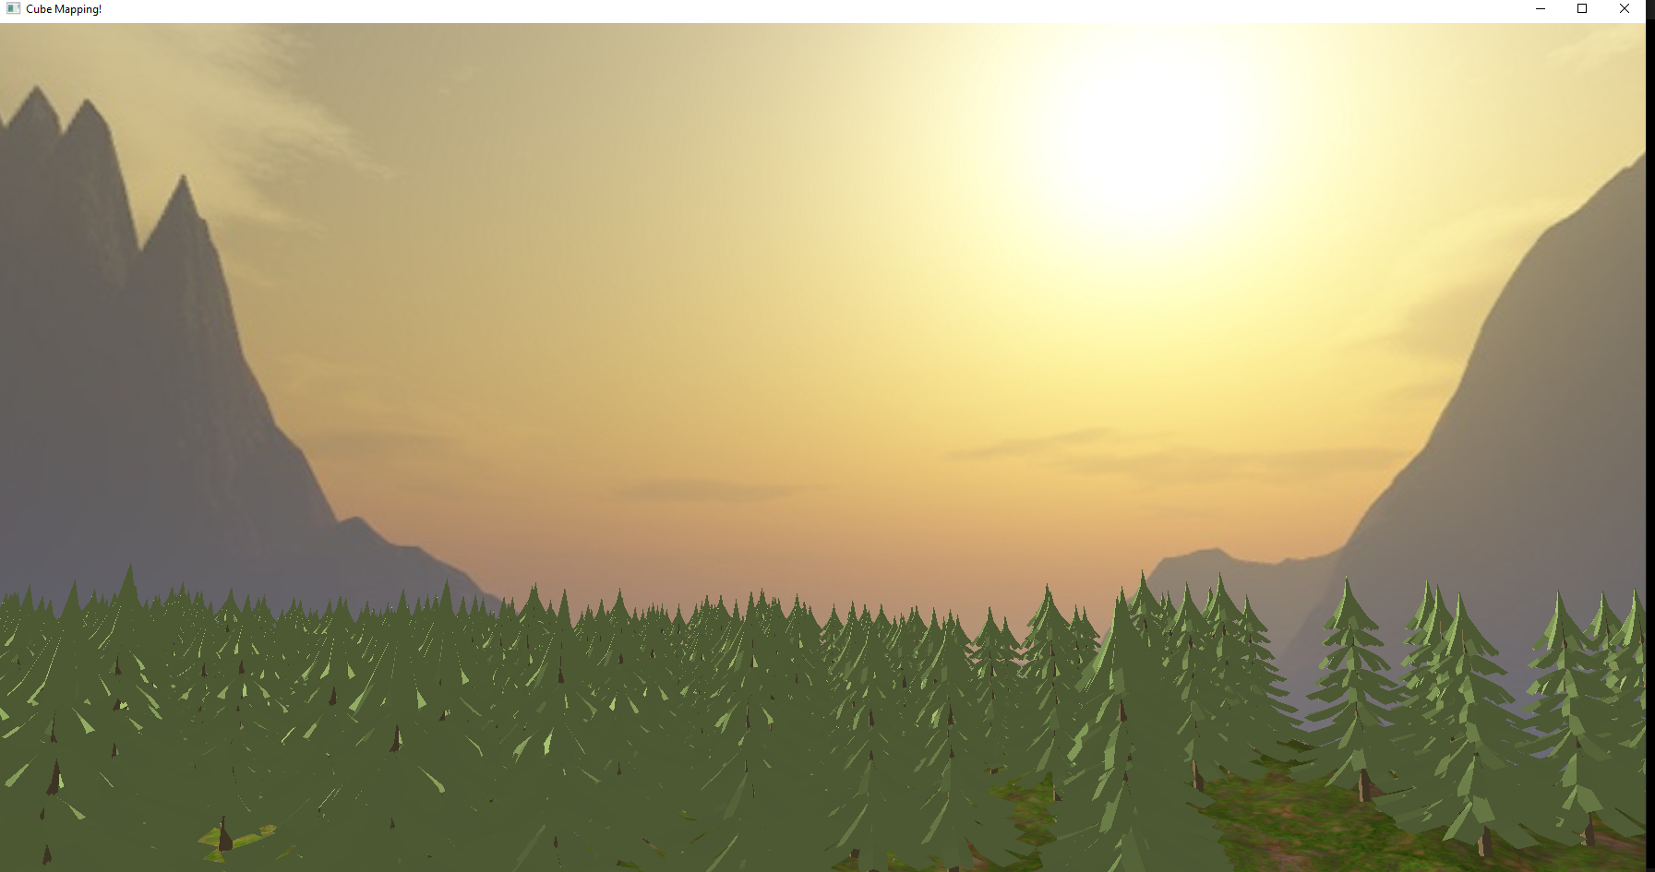

Night time

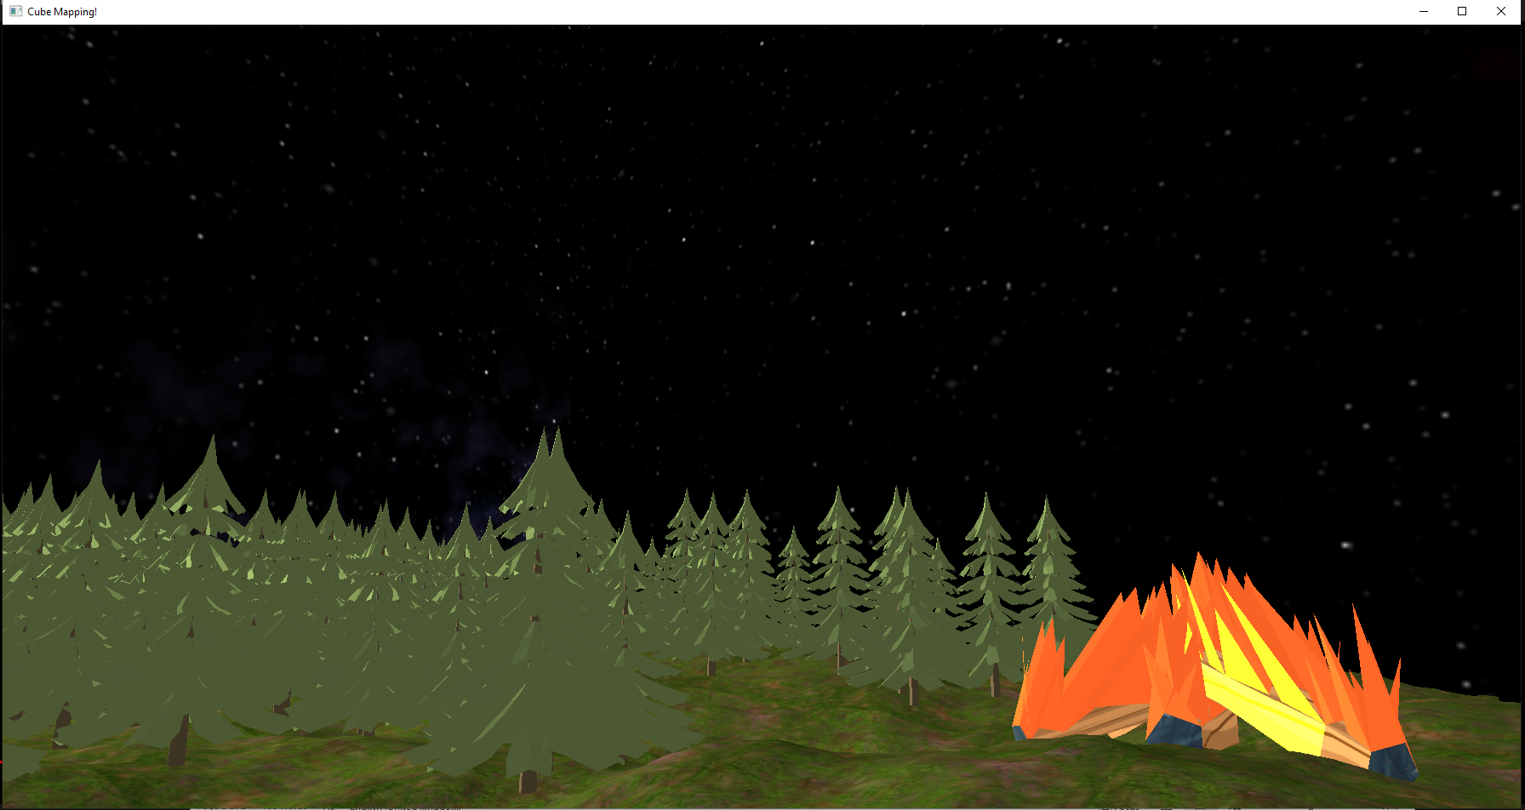

Fire is rendered by geometry

60 fps

Automated and manual camera movement

Video Link

<https://youtu.be/cCUtHUu_zAU>